**CS Symposium System**

Senior Project Proposal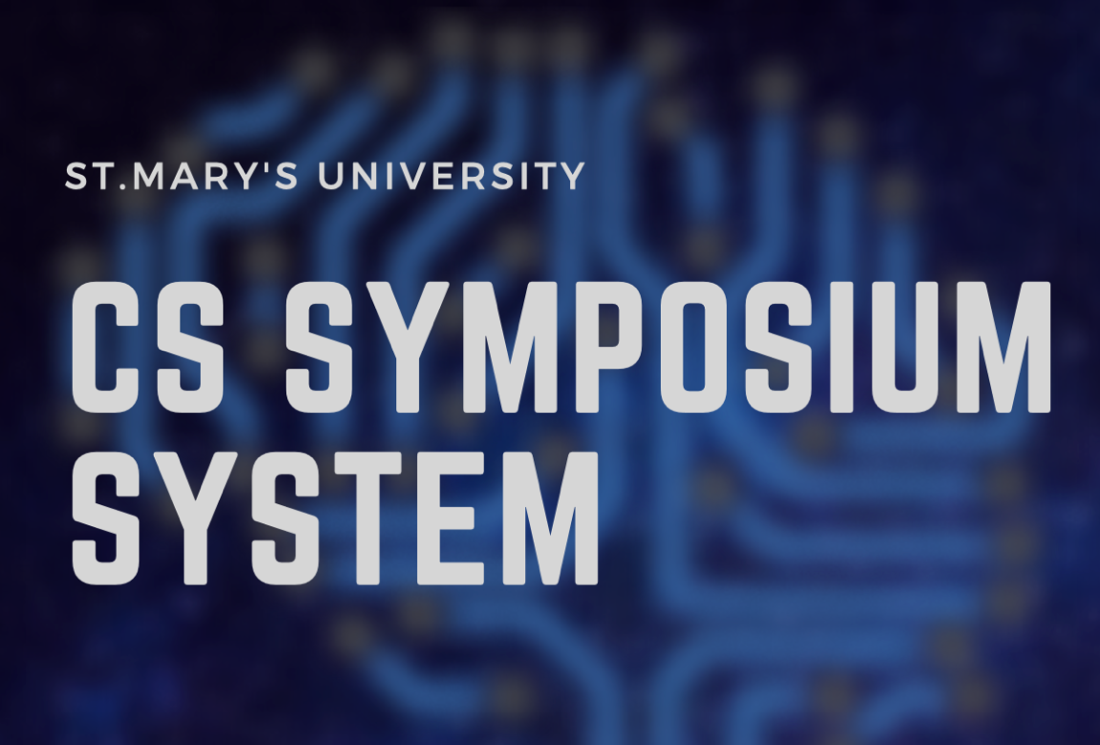

Abdulmohsin Alyafee

*aalyafee@mail.stamarytx.edu*

*Spring 2019*

Contents

Overview 1

Motivation 2

Analysis 3

Design 4

Plan 5

Cost Estimate 6

References 7

Overview

**Problem/Issue** CS Symposium is an end of semester gathering of StMU’s CS students presenting their work that is judged by industry experts. The Computer Science Department at St. Mary’s University invites more than 18 people of industry experts, and their tasks are to judge students’ projects. The CS department provides all the judges with papers to give feedback of each project. At the end of the Symposium’s, the department faculties collect and count all papers from judges in order to identify the winners. While the faculties are counting, guests and judges would be waiting for the result for about 30 minutes. With Technology, the process of counting could be done in about a second. Which will reduce count time by %99. **Solution**

Switching paper-based voting to an Electronic voting system for the CS symposium would allow the judges and guests to see the proposal, abstracts, event information, and floor map of each the presenter via the symposium app system. Furthermore, the system will allow the judges to vote and write notes during the presentations. At the end of the symposium, the system will calculate the scores and display participators those who have the most votes.

Motivation

After being a volunteer twice as a timekeeper at the CS symposium, time actually matters in events such as the CS symposium. The process speed of counting results matters as well. Guests usually spend 30 minutes after all presentations are done waiting to hear the results. It is true that it is a break where everyone gets to eat snacks after all presentations are done; however, several people would be counting the voting at that moment and not enjoying the moment of having a conversation with the guests.

**Benefits**

The Computer Science Department would have the ability to expand and run the CS Symposium event smoothly; additionally, greater number of students and judges can be hosted since the evaluation sheets are being calculated electronically. Dr.Hanna, a professor in the CS department, is responsible for collecting and counting more than 80 evaluation sheets from the judges. The application would surly ease the burden from Dr,Hanna.

Analysis

Many questions were asked about this issue in order to emphasize the problem. The main concern was if this product would be beneficial to the CS Department. Other questions were, how does the evaluation work and how many types of evaluation sheet. Two professors from the Computer Science Department at St. Mary’s university provide valuable answer to these questions. For example, each subject has its own evaluation sheet; thus, each subject are being evaluated differently. Dr.Redfield and Dr.Hanna have thought that this product would make the CS Symposium run effortlessly or smoothly.

**Functionalities**

In the main page, the system will display four buttons such login, floor map, student’s material, and schedule at glance. When the user presses the floor map button, the system will display the floor map of Richter Math Engineering building. If user select schedule at glance button, the system will display the schedule.

There will be two type of user for the website. First, the admin user which will have more functionalities. The admin would be able to add student material in ordered to be downloaded, view filled evaluations, view the winners of each subject, and send judge’s comments to the presenters. Second type of account is for the judge’s, which has less functionalities. The judge has the ability to evaluate the students through the evaluations page.

Design

**Environments**

JetBrains, phpMyAdmin, and Appy Pie are three tools that will be used in order to implement the product. Each of these tools has its own benefit. JetBrains is a software development company whose tools are targeted towards software developers and project managers. JetBrains tool can take JavaScript, HTML, CSS, and SQL, etc. Thus, the developer is not in need to have multiple compilers because JetBrains has the feature to run different language as was mentioned previously. In addition, they offer a free membership for college students. Also, I have an experienced using JetBrains from a previous project which make me use an familiar tool. Using unfamiliar tool could be risky in terms of wasting time.

PhpMyAdmin is an open source administration tool for MySQL. It is one of the most popular MySQL administration tools, especially for web hosting. My project will be an application website; thus, using this tool will help me to upload my database in the web server. There must be a web server in order link the database to the web application; in fact, I will be using Xammp web server to connect the database with my application website.

**Use Case Diagram**

This use case diagram shows the functionalities of each user account.

A close up of text on a white background


**Tables**

The admin account has access to add new student’s information. The judge’s evaluation and comment will be written on the project table.

A screenshot of a cell phone


**System Structure**

This Data flow diagram illustrate how each account logs in to system .

A close up of text on a black background


**Interfaces**

Display the Main Page

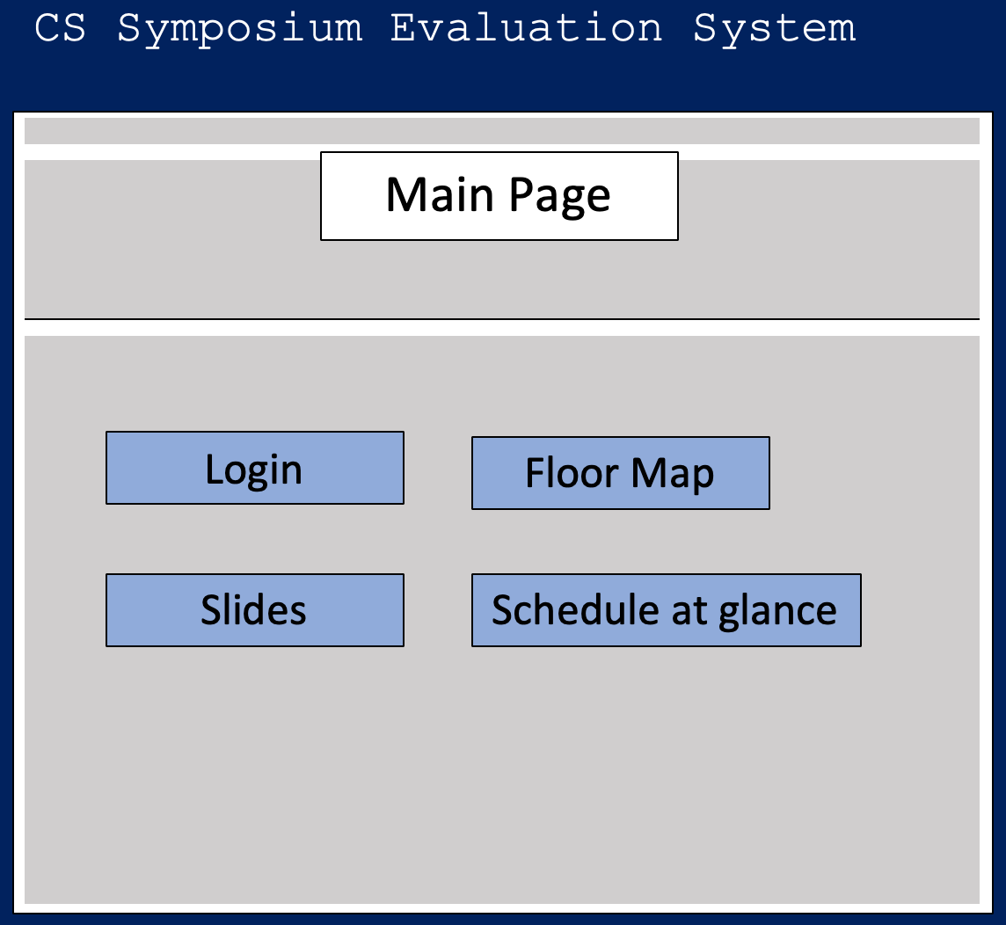

Sign in or Sign up

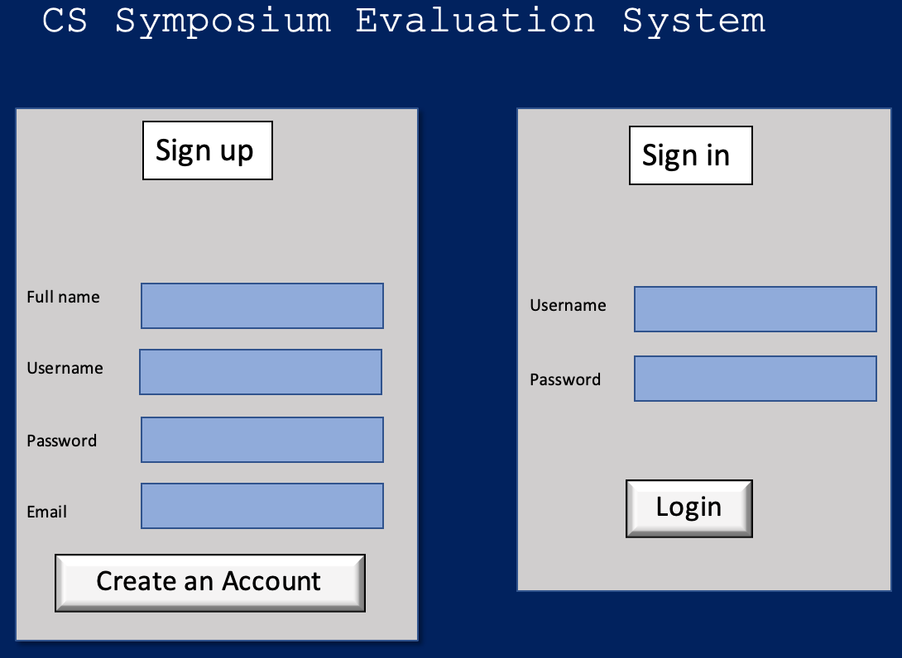

Select current Presenter 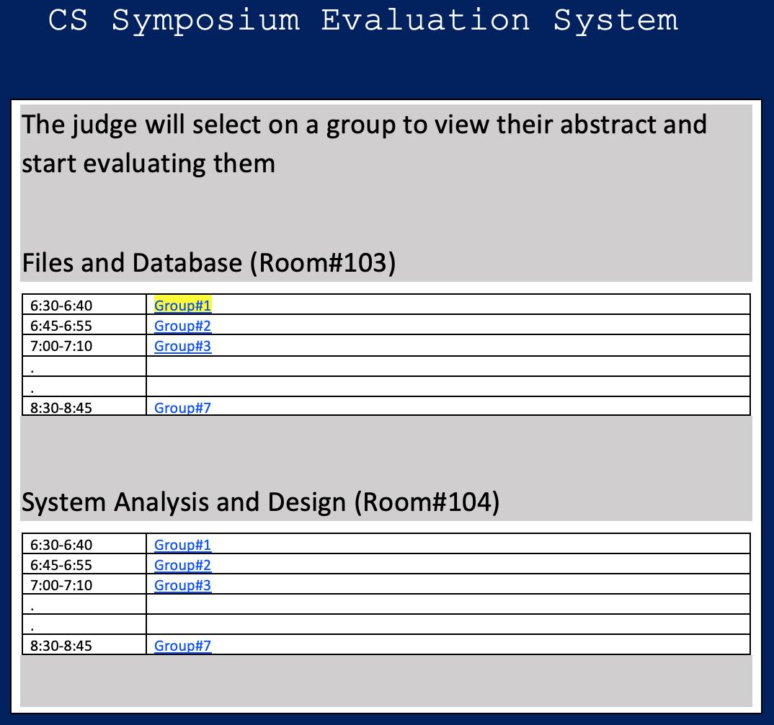

Display the Abstract and start evaluation button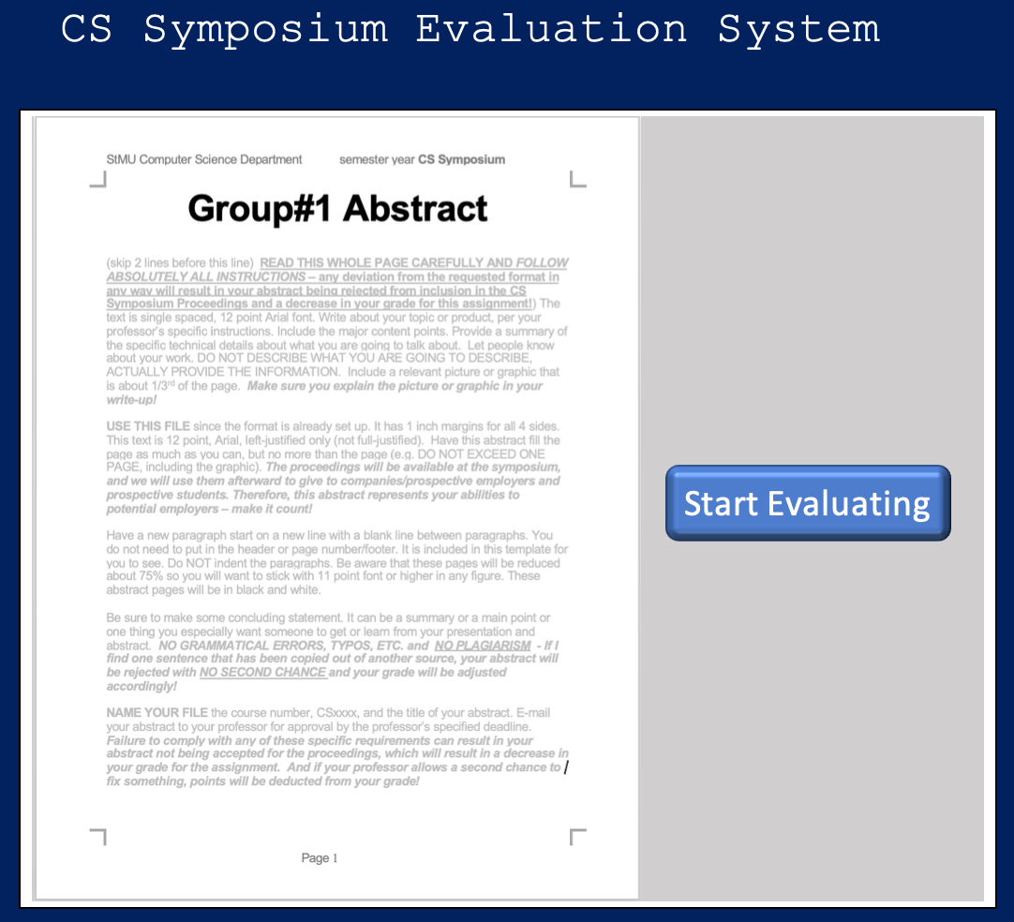

Display the evaluation sheet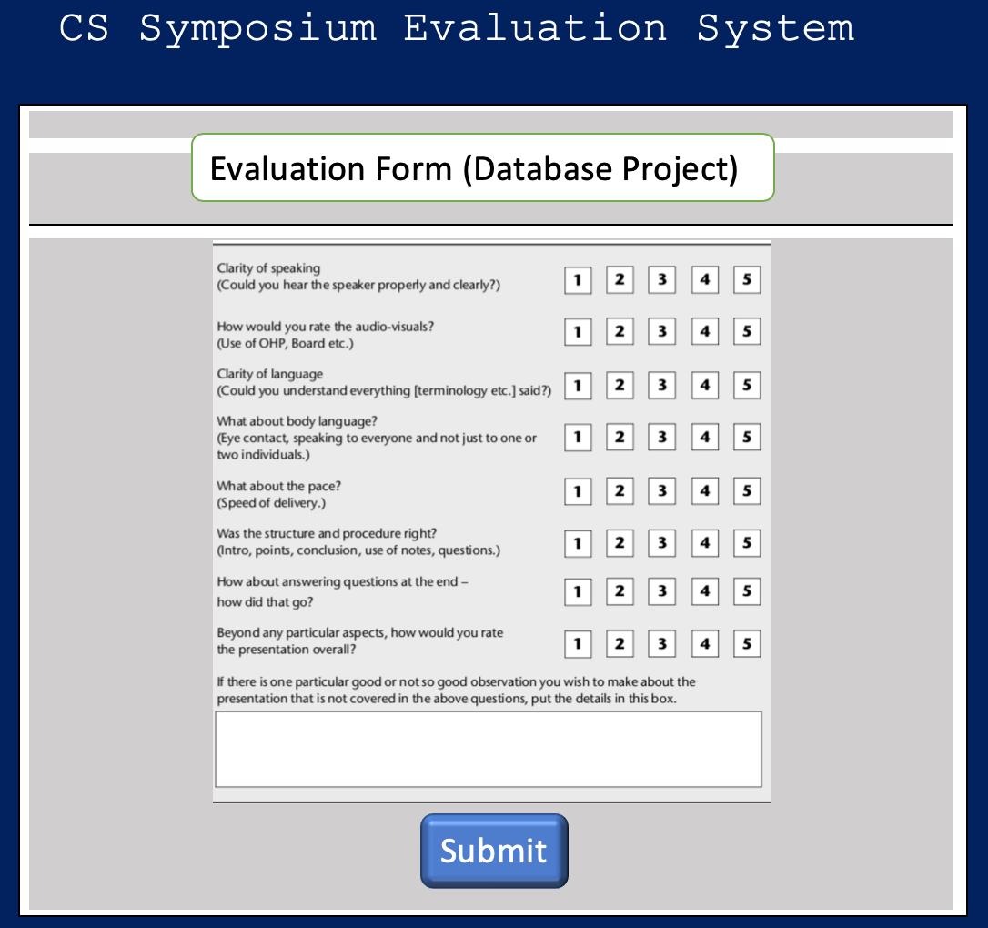

Selects an option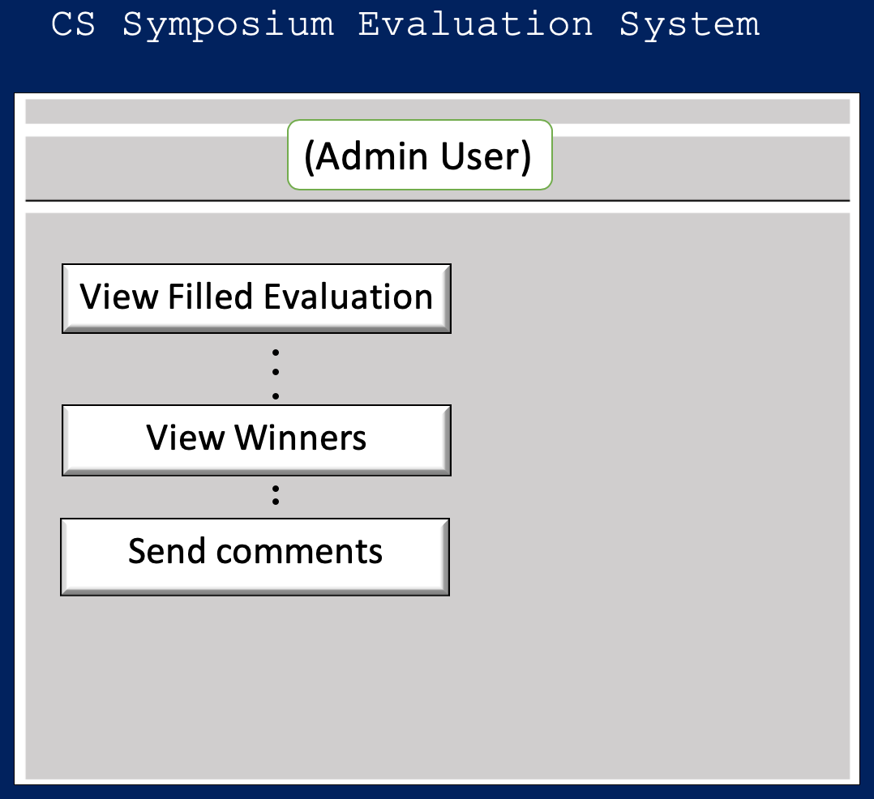

Selects a subject to view its winner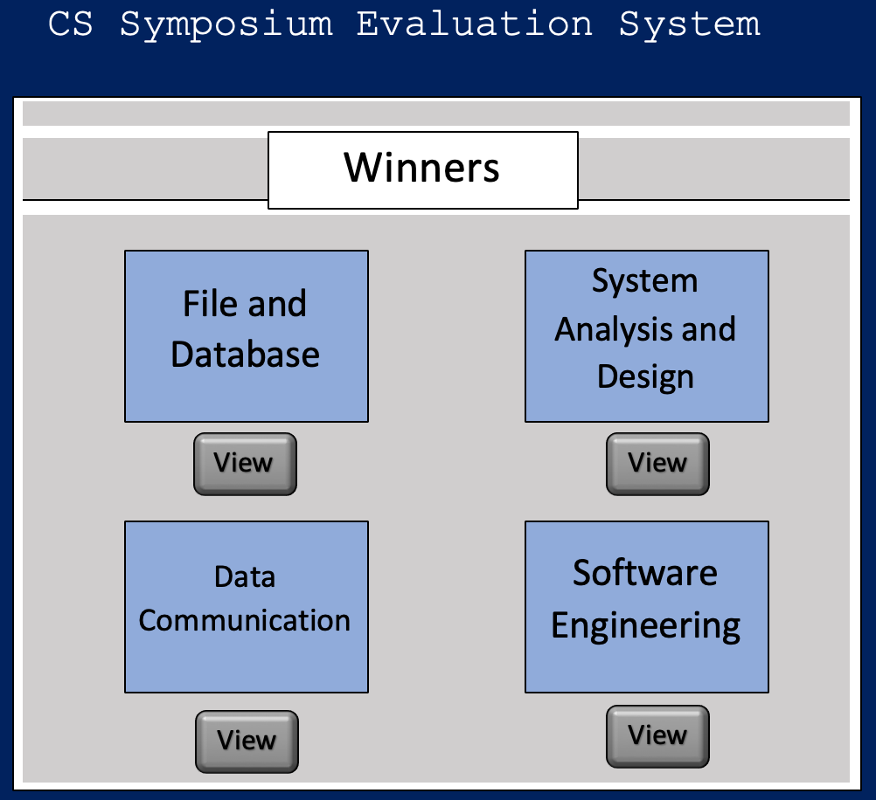

Display the winner of the selected subject

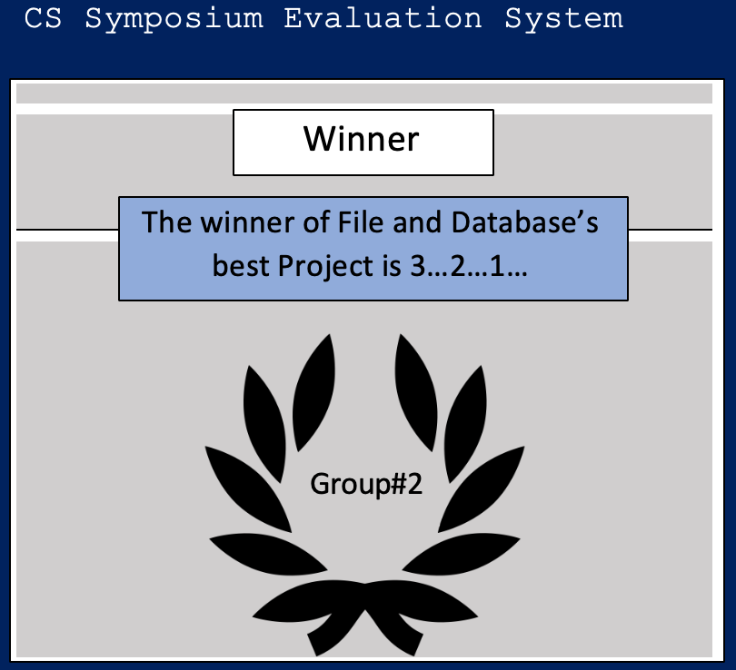

Display floor map 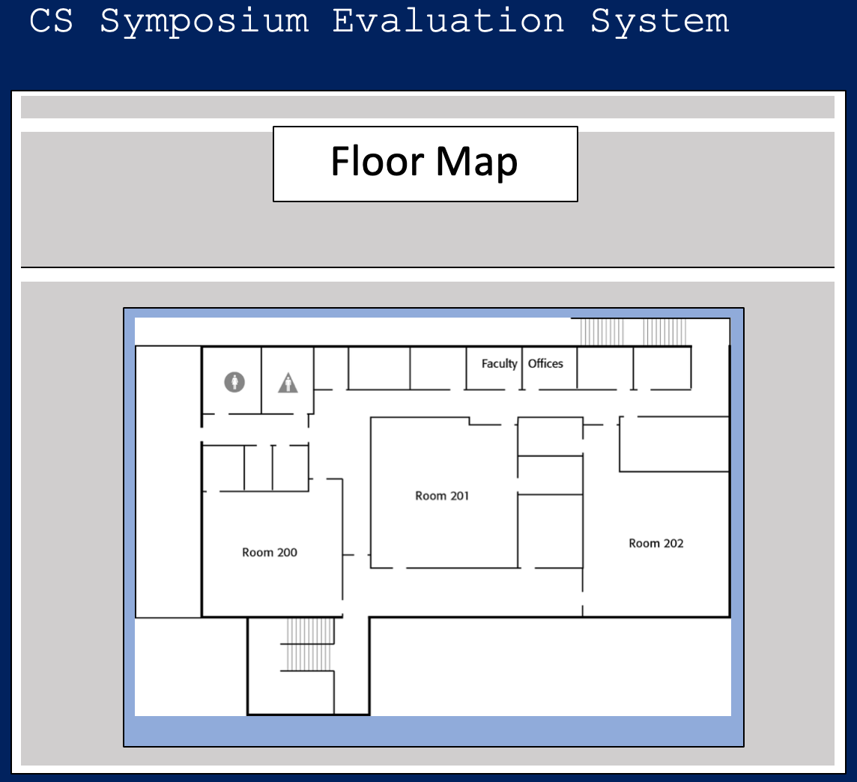

Plan

**Schedule**

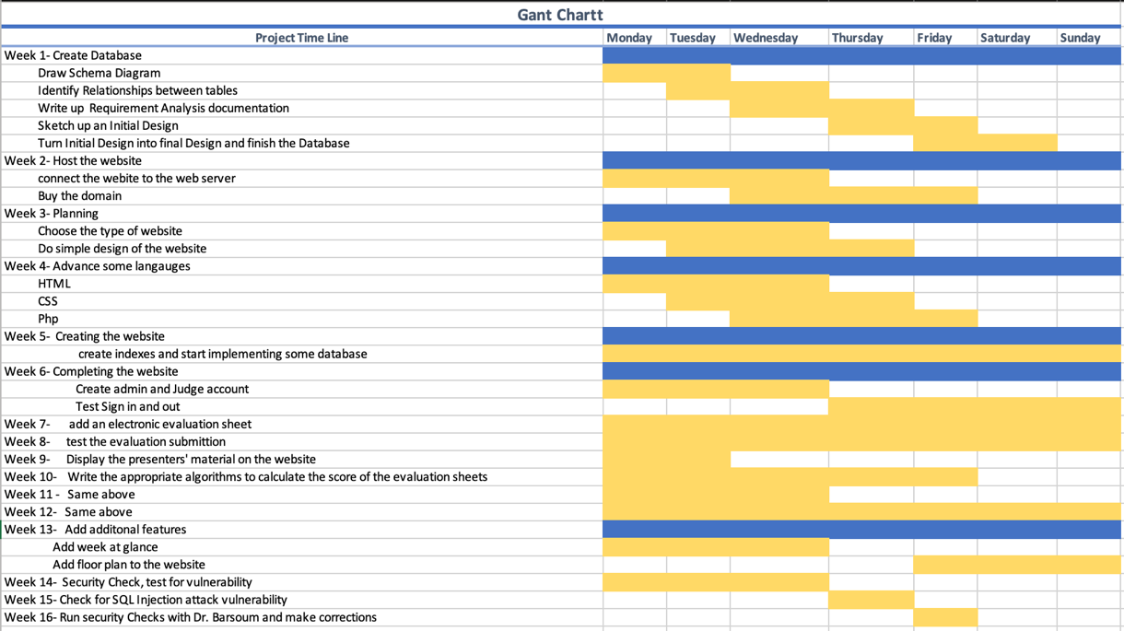

Cost Estimate

**Materials**

In terms of software tools, JetBrains, phpMyAdmin, and xampp will used. All of these software tools are free. MacBook Pro 2015 will run these software tools perfectly.

**Cost Calculation**

Some of the tools that I will be using are free such as JetBrains and phpMyAdmin. However, there is a chance of using Appy Pie which cost around $50 per year. This tool converts the website to a mobile app. A laptop will be needed in order to develop the website, and it costs $1000(MacBook). The total that will be spent to make this project are 150 hours. $25 per hour is my cost for making developing the project. Thus, the total amount of making of the project including the software and hardware requirements is $3800.

References

1. <https://www.godaddy.com/tlds/life-domain> (October 12th,2018)
2. <https://support.google.com/chrome/answer/95346?co=GENIE.Platform%3DDesktop&hl=en> (November 2,2018)
3. <https://goo.gl/images/ux9nLk> (November 25, 2018)
4. <https://goo.gl/images/SYeYcN>(October 17,2018)
5. <https://www.appypie.com> (November 12,2018)